WEEK 4 • COMPREHENSIVE DATA SCIENCE REPORT
MEALCYCLE AI
From Forecasts to Decisions: A Data-Driven Framework for Reducing Cafeteria Food Surplus
Submission Details | Information
Student Name | ____________________________
Course / Programme | ____________________________
Subject | Data Science / Python
Assignment | Week 4 – Comprehensive Data Science Report & Insights Presentation Plan
Faculty / Guide | ____________________________
Date of Submission | ____________________________
Portfolio focus: Predictive Analytics • Responsible AI • Decision Support
All numerical examples and charts in this planning report are illustrative because no dataset was supplied.

1. Executive Summary
MealCycle AI is a proposed data science solution for helping institutional cafeterias anticipate food surplus and make better preparation decisions. The system addresses a practical question: how can historical demand and contextual information be converted into a useful forecast before the next meal service?
The framework combines data preparation, exploratory analysis, predictive modeling and decision-oriented visualization. Potential inputs include meals prepared, meals sold, aggregated attendance, menu characteristics, calendar conditions, events and weather. The main analytical output is an estimate of expected surplus meals. Rather than presenting a model score as the final answer, the forecast is translated into understandable action categories that cafeteria staff can review.
Because no dataset is provided, this report clearly separates the analytical framework from hypothetical findings. The charts are mock-ups demonstrating how future results could be communicated and should not be interpreted as real cafeteria measurements. The proposed solution emphasizes predictive accuracy, operational usefulness and responsible communication. A successful implementation would seek to reduce avoidable surplus without increasing meal shortages.

2. Project Context and Business Question
Cafeteria production is a decision under uncertainty. Demand may change with attendance, weekday patterns, examinations, holidays, menu preferences, events and weather.
Core business question: How can data be used to anticipate meal surplus early enough for cafeteria teams to make a better preparation decision?
- Which factors are most associated with surplus?
- Are there recurring weekly or seasonal patterns?
- Which conditions create unusually large forecasting errors?
- Does machine learning improve on a simple baseline?
- How can a numerical forecast be translated into an understandable operational recommendation?

3. Methodology Overview
The proposed workflow moves from data understanding to insight generation and finally to decision support.
Stage | Method | Expected Output
Data understanding | Schema review, data dictionary, quality checks | Trusted analytical dataset
EDA | Univariate, bivariate and multivariate analysis | Patterns and anomalies
Feature engineering | Lag, rolling, calendar, attendance, menu and event variables | Predictive feature set
Modeling | Baseline plus regression candidates | Forecasting models
Validation | Chronological validation and future hold-out | Reliable performance estimate
Interpretation | Feature diagnostics and error analysis | Explainable findings
Decision layer | Action bands and guardrail KPIs | Operational recommendations
Communication | Executive visuals and narrative | Stakeholder-ready report

4. Insights and Analysis – Hypothetical Findings
Since no dataset is supplied, these are testable hypotheses rather than claims about real observations.

4.1 Weekly pattern
The future analysis may reveal that surplus is not evenly distributed across the week. A line chart is suitable for identifying recurring temporal patterns.
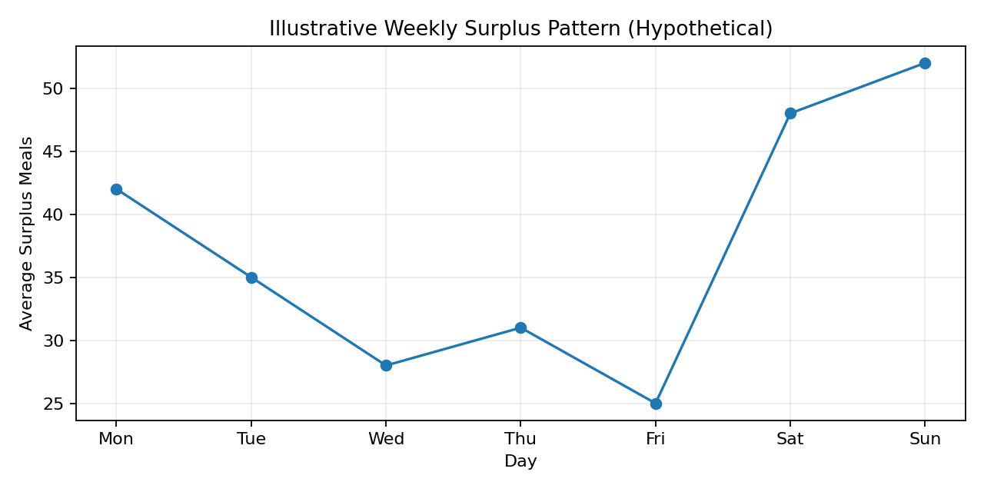
Figure 1. Illustrative weekly surplus pattern — hypothetical mock-up.

4.2 Attendance relationship
Attendance may explain part of the variation in surplus, although the relationship should not be interpreted as causal without further analysis. A scatter plot helps reveal direction, strength and unusual observations.
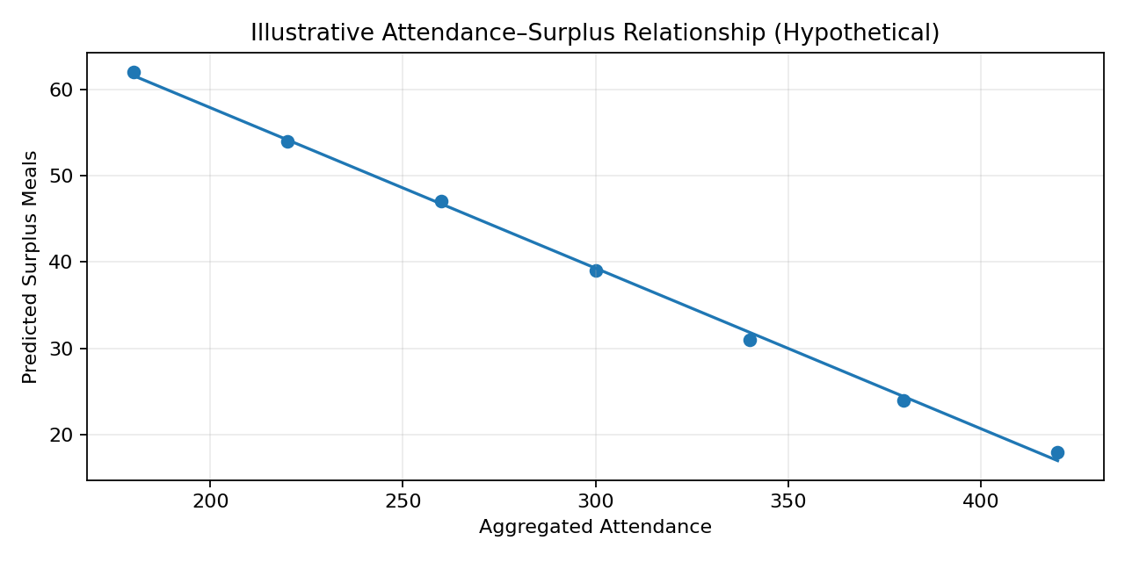
Figure 2. Illustrative attendance-surplus relationship — hypothetical mock-up.

4.3 Events and anomalies
Holidays, examinations or special events may create unusual observations. Such records should be investigated rather than automatically deleted, because they may contain useful information for future predictions.

4.4 Model value
A machine-learning model should only be considered valuable if it improves on a reasonable historical baseline and maintains stable performance across time. MAE, RMSE and error patterns would therefore be reported together.

5. Visualization Strategy
Question | Visual | Purpose
How is surplus distributed? | Histogram + box plot | Show spread and outliers
How does surplus change over time? | Line chart | Reveal trends and seasonality
Which categories differ? | Sorted bar chart | Compare groups clearly
Does attendance relate to surplus? | Scatter plot | Show relationships and exceptions
Which variables move together? | Correlation heatmap | Summarize multivariable relationships
Where does the model fail? | Actual vs predicted | Reveal systematic errors
Which factors matter? | Feature importance | Explain model drivers
What action follows? | Decision-band table/KPI cards | Translate analytics into action

5.1 Visualization Principles
- Use titles that state the question or takeaway.
- Label axes, units and time periods clearly.
- Avoid decorative 3D charts and unnecessary visual complexity.
- Use consistent terminology across all visuals.
- Highlight anomalies only when they contribute to the analytical story.
- Keep executive visuals concise and move technical detail to supporting sections.

6. Actionable Insights
The final report should distinguish an observation from an insight and from an action.
Evidence Pattern | Potential Insight | Potential Action
Repeated high surplus on one day | Production may consistently exceed demand. | Review preparation quantity and attendance assumptions.
Surplus varies with attendance | Expected population may be an important driver. | Include attendance in forecasting.
Large errors during events | Ordinary-day features may miss event effects. | Add event indicators and expected attendance.
Model improves MAE over baseline | ML provides measurable forecasting value. | Consider a controlled pilot with human review.
Waste falls but shortages rise | Single-objective optimization creates operational risk. | Track surplus and stockouts together.
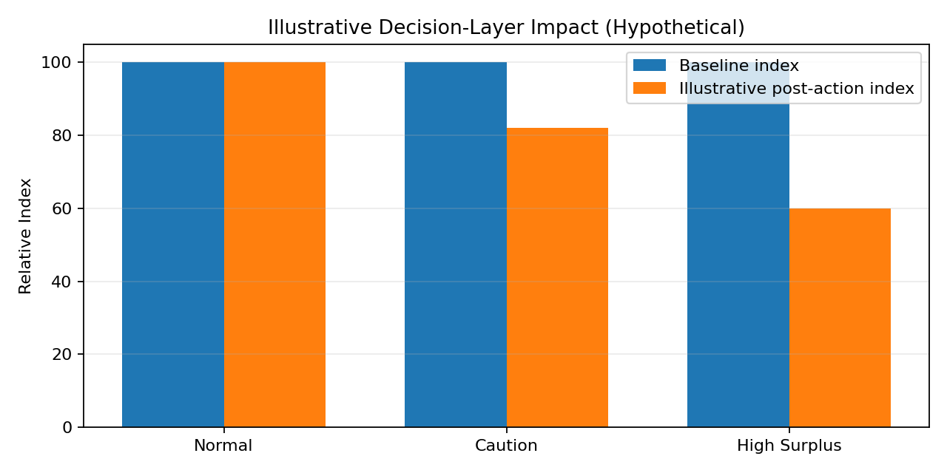
Figure 3. Illustrative decision-layer impact — hypothetical index for presentation design only.

7. Recommendations for Future Work
- Collect sufficient historical data across weekdays, seasons, menu cycles and special events.
- Create a formal data dictionary and quality-monitoring process.
- Use attendance only in an appropriate aggregated form.
- Benchmark ML against a simple baseline before deployment.
- Maintain chronological validation and monitor model performance after implementation.
- Introduce human review for operational recommendations.
- Track stockouts as a guardrail so waste reduction does not reduce meal availability.
- Consider Power BI or Streamlit as a future presentation layer after the predictive pipeline is validated.

8. Communication Strategy for Non-Technical Stakeholders
The presentation will lead with the business problem rather than algorithms. The narrative will move from context to evidence, prediction, interpretation and action.
Step | Stakeholder Message
1. Context | We must prepare food before exact demand is known.
2. Evidence | Historical patterns show that demand changes under identifiable conditions.
3. Prediction | The model estimates likely surplus for the next service.
4. Interpretation | These factors contribute most to the estimate.
5. Action | This forecast supports a specific preparation response.
6. Guardrail | Shortage risk is monitored alongside waste reduction.
Technical Term | Plain-Language Translation
MAE | Typical number of meals by which the forecast is wrong.
RMSE | A measure that gives more weight to large forecasting mistakes.
Feature | A piece of information used to make the prediction.
Model drift | The model becomes less reliable as conditions change.
Baseline | A simple method used to check whether ML adds value.

9. Proposed Executive Presentation
Slide | Content | Suggested Visual
1 | Problem and objective | One headline + problem graphic
2 | Why demand is uncertain | Factor diagram
3 | Data and approach | Analytics pipeline
4 | Key pattern | Trend chart
5 | Important relationship | Scatter/bar chart
6 | Model performance | KPI cards + actual/predicted
7 | What drives prediction | Feature-importance chart
8 | Recommended action | Normal / Caution / High Surplus
9 | Risks and guardrails | Risk matrix
10 | Next steps | Implementation roadmap

10. Limitations, Assumptions & Responsible Use
- No real dataset is available for this planning assignment; charts and numerical examples are illustrative.
- Associations should not automatically be treated as causal relationships.
- Forecast accuracy depends on data quality and whether future conditions resemble historical conditions.
- Unexpected events may create errors that historical data cannot anticipate.
- Aggregated attendance is preferable to individual-level tracking.
- Predictions should support rather than replace operational judgment.
- Future deployment should monitor both surplus and stockout outcomes.

11. 33-Hour Week 4 Work Plan
Workstream | Hours | Output
Executive summary and report structure | 4 | Polished narrative and report framework
Analytical findings framework | 5 | Hypothesis-driven insight plan
Visualization mock-ups | 6 | Charts, tables and rationale
Actionable insight mapping | 4 | Evidence → insight → action
Stakeholder storytelling | 4 | Executive presentation structure
Recommendations and future work | 3 | Prioritized roadmap
Quality review and formatting | 3 | Professional final document
GitHub portfolio packaging | 4 | README, report and visual assets
TOTAL | 33 | Complete Week 4 plan

12. Evaluation Criteria Mapping
University Criterion | How This Report Addresses It
Clarity and comprehensiveness | Covers executive summary, methodology, findings, visuals, insights and recommendations.
Actionable insights | Separates evidence, interpretation and recommended action.
Quality of visual aids | Uses purpose-driven mock-up charts and tables.
Strategic communication | Provides a dedicated non-technical storytelling framework.
Analytical understanding | Connects EDA, prediction, validation and interpretation.
Professional presentation | Includes a recruiter-friendly portfolio and GitHub packaging strategy.

13. Portfolio & GitHub Presentation
For recruiter-facing use, the repository should allow a reviewer to understand the business problem, analytical approach and project status within a few minutes.
MealCycle-AI/
├── README.md
├── docs/
│ ├── Week1_Project_Plan.docx
│ ├── Week2_EDA_Framework.docx
│ ├── Week3_ML_Model_Plan.docx
│ └── Week4_Comprehensive_Report.docx
├── reports/
│ └── figures/
├── notebooks/
├── src/
├── data/
│ └── README.md
└── requirements.txt
Recruiter-facing project statement: Designed a Python-based data science framework to forecast cafeteria food surplus, combining exploratory analysis, feature engineering, regression modeling, time-aware validation and decision-oriented visualization. The project balances waste reduction with stockout risk and emphasizes responsible communication to non-technical stakeholders.

14. Conclusion
MealCycle AI integrates the analytical and strategic components of a complete data science project. The reporting framework treats visualization as an analytical tool rather than decoration: every chart is selected to answer a question and support a decision. Model evaluation is likewise presented in operational terms so that stakeholders can understand both predictive performance and its limitations.
The project recognizes that a technically accurate model is not automatically a useful business solution. A credible system requires a baseline comparison, realistic validation, error analysis, monitoring and human judgment. Although the Week 4 report is based on a hypothetical dataset, it provides a structured blueprint for future implementation and a professional portfolio artifact suitable for university assessment and recruiter review.

